Barton Chapel Elementary

Kindergarten School Supply List

You may want to get “separate” special supplies to keep at home for homework.

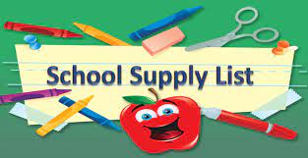

* Book bag (change of clothes)
* Pencil box/pencil case
* 1 Box of Crayon (24 colors)
* 1 Pack of Pencils #2
* Plastic two-pocket folders (3)
* 2 one-subject spiral notebooks
* Hand sanitizer
* Box of Kleenex Tissues
* 1 Pack of Glue sticks
* Erasers
* Ziploc bags (quart size)
* 2 Primary Tablets
* Wide Rule Paper
* 1 Pkg of Wipes
* 1 Pair of Headphones

